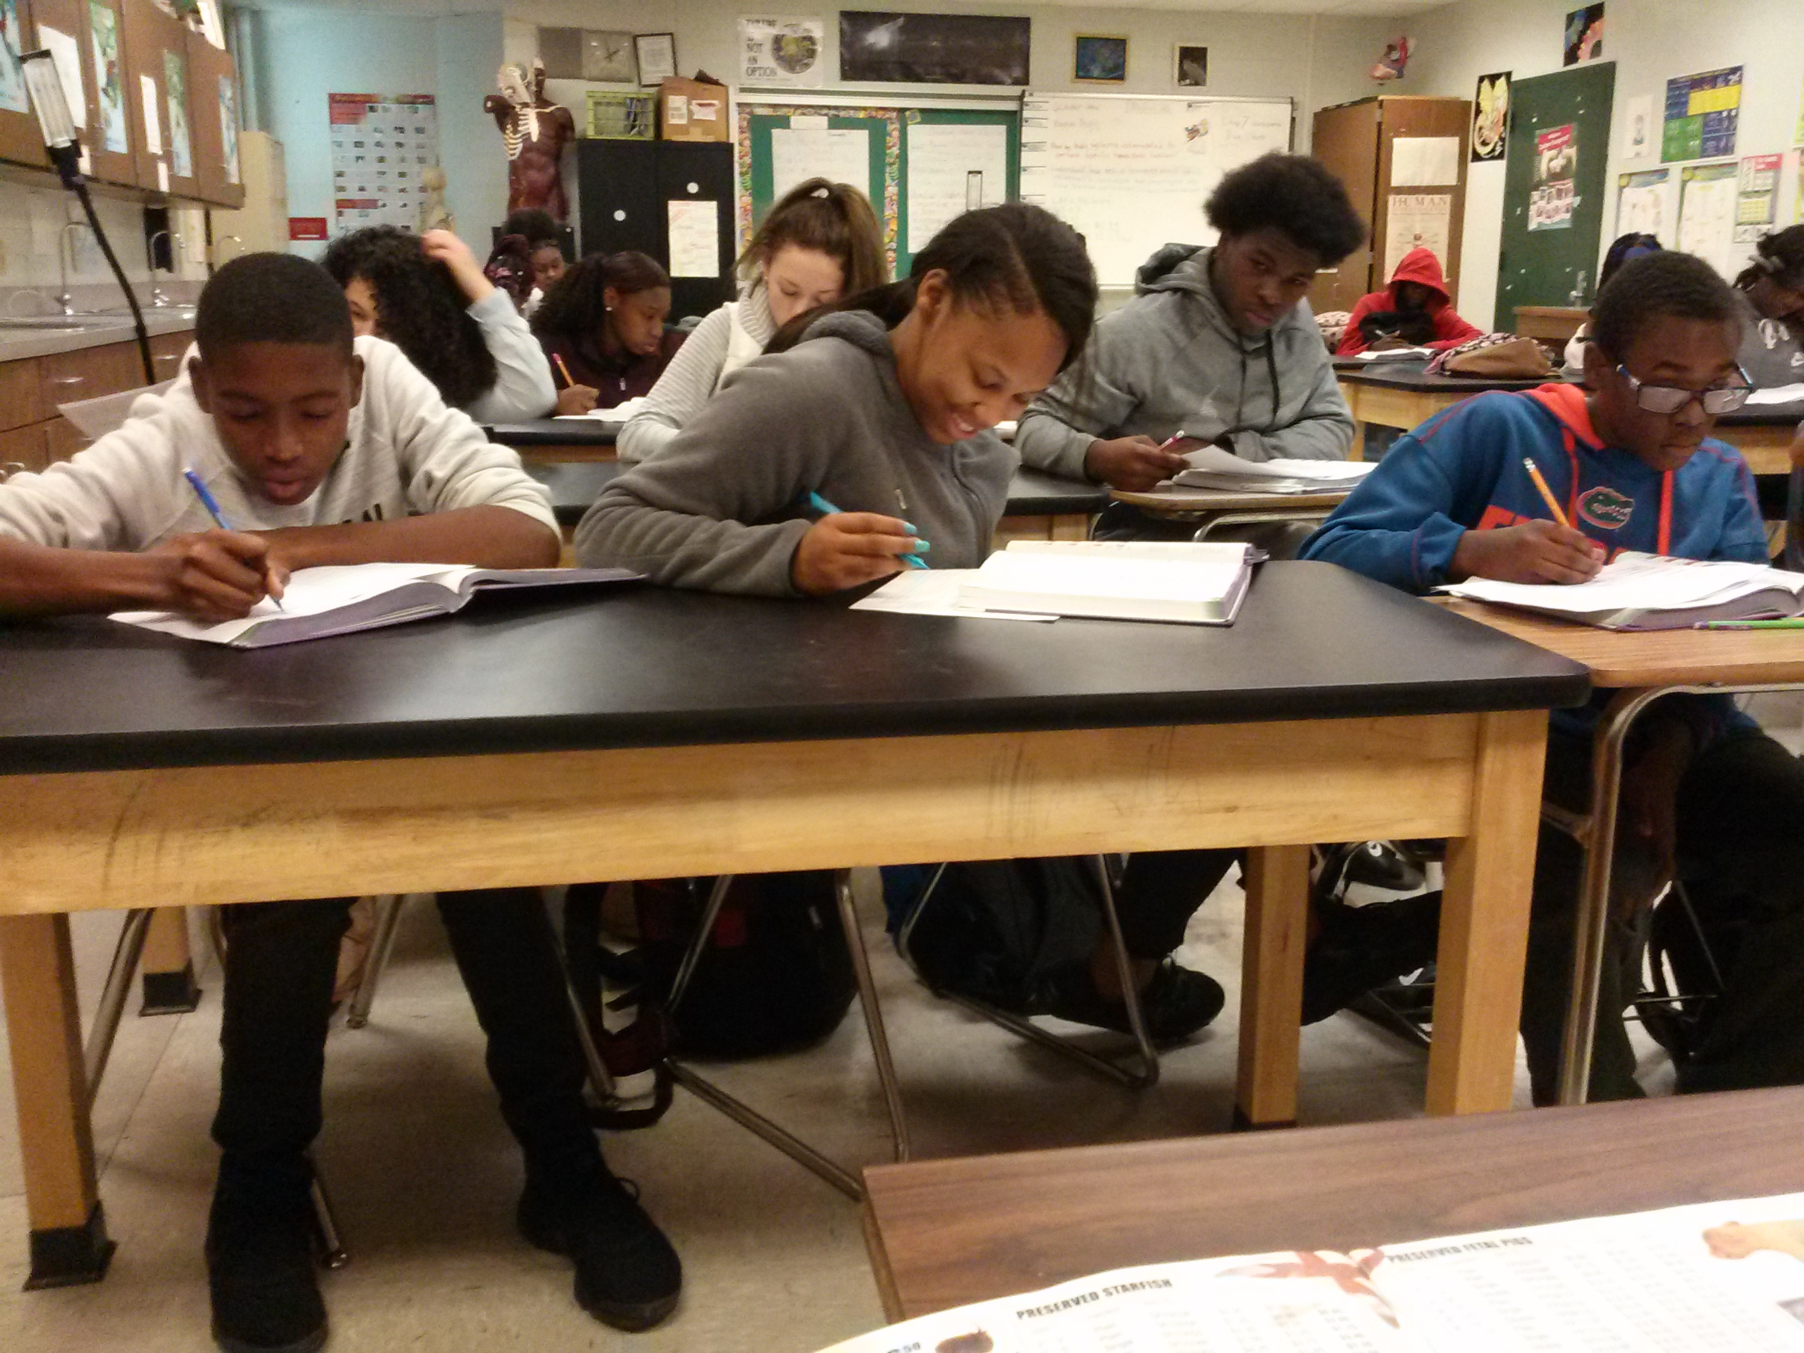  Are you interested in a career in health care and are zoned for EHS next year?  This is a four year Health Science program that will allow for an individual to gain knowledge and skills in a medical profession. Upon completing the program and passing the certification, you can begin a promising healthcare career STRAIGHT OUT OF HIGH SCHOOL. | Who can you ask if you have questions?  Mrs. Adele Turnage  Assistant Principal  Eastside High School  Contact Info  Phone: 352-955-6704  Email: turnagas@gm.sbac.edu  http://eastside.sbac.edu/pages/EHS0421  Medical skills program  1201 SE 43rd St. Gainesville, FL 32641 | Medical skills program  - For students zoned to Eastside High School
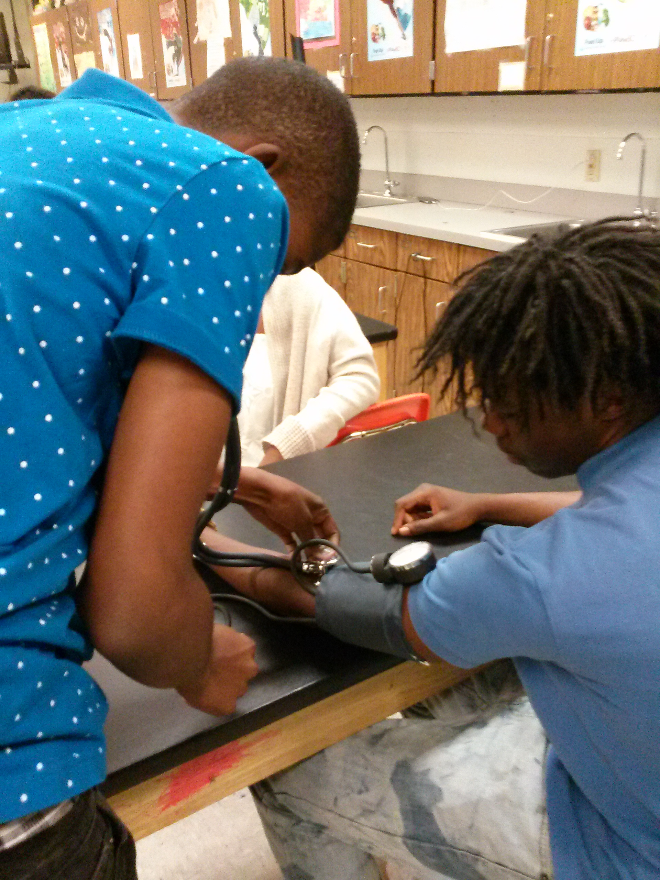  Taking blood pressure  What industry certifications are possible?  Here are a few….  - Rehabilitation Aide  - Certified Nursing Assistant  - Sterile Supply Tech | What courses do you have to take?  - Medical Science & Skills  - Health Science Anatomy & Physiology  (which carries honors weight)  - Health Science Foundations  (which carries honors weight)  - Allied Health Assisting 3  Sign up and get a head start on a great career! | 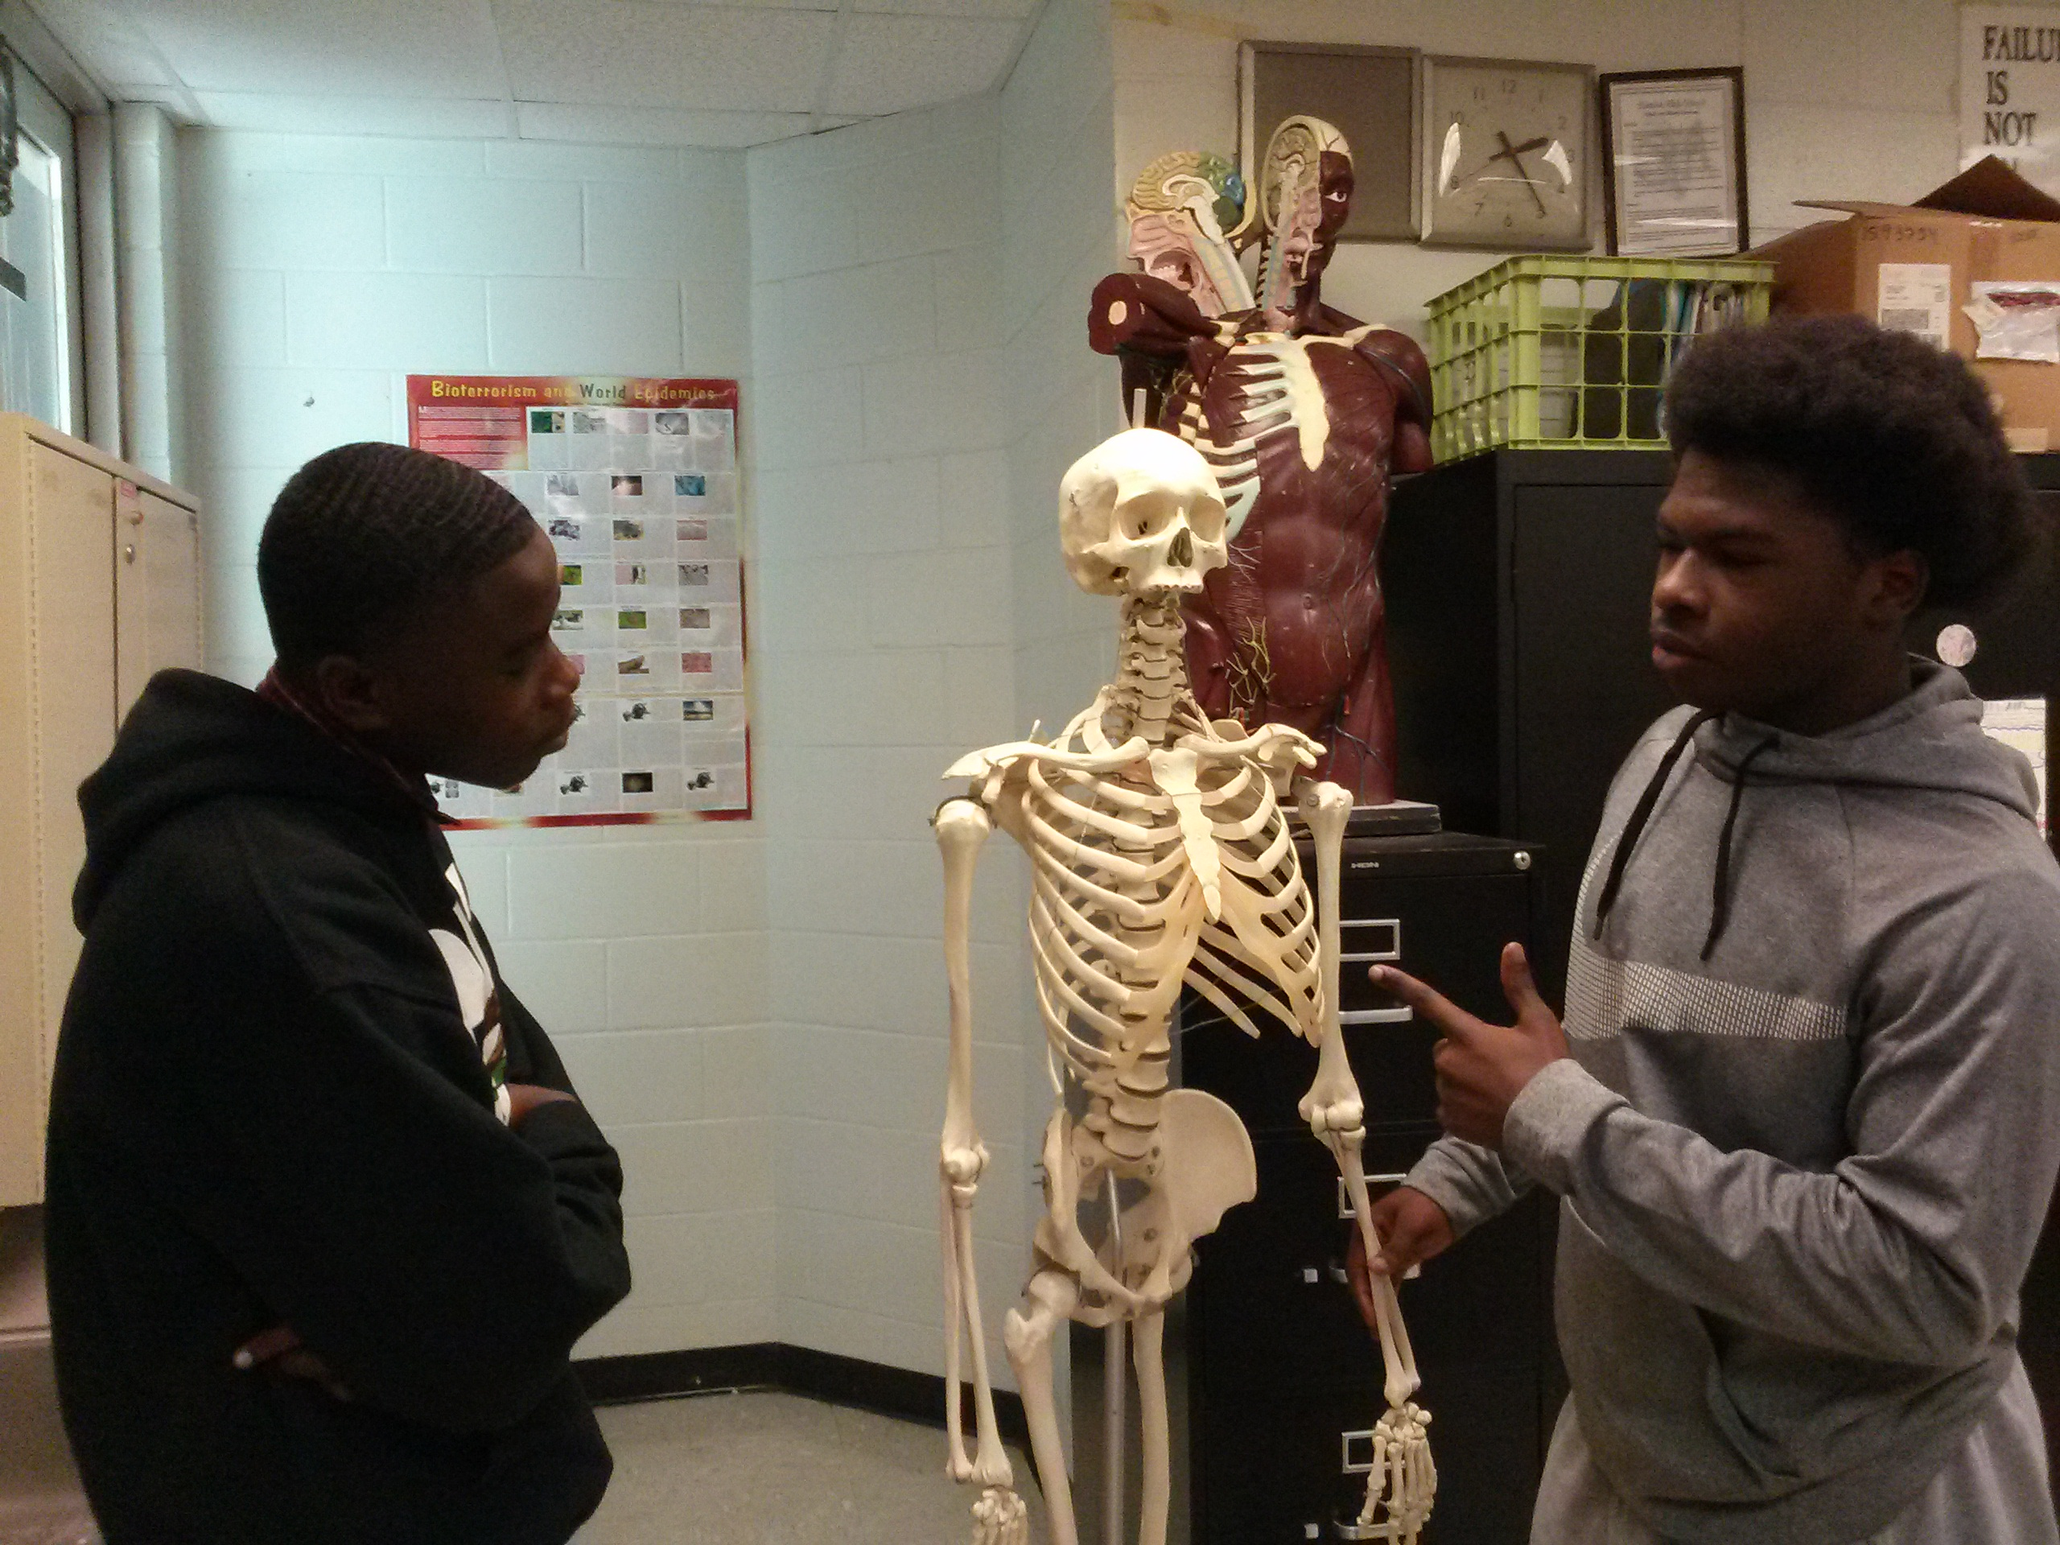  Learn Anatomy  8th Graders:  When it is time to register for your high school courses, be sure to register for the class at EHS called:  MEDICAL SKILLS AND SERVICES

